**Week4**

**PORTFOLIO**

**Assessment Weightage & Type:**

**60% Portfolio Coursework**

**Year:2024**

* Student Name: Pratha Sharma
* UWE ID: 24030176
* Module code: **UFCFL1-15-0**
* Level: **Level 3)**
* Faculty: **Faculty of Internet & Technology**
* Department: **FET Department of Computer Science & Creative**

**Technology**

**Task 1 - Getting started with moqups.com account setup and tools overview**

1. Create a free account in moqups.com. Follow with the click on the a Create a Free Account. You can get

this screen. Let’s go with Sign up with Google.

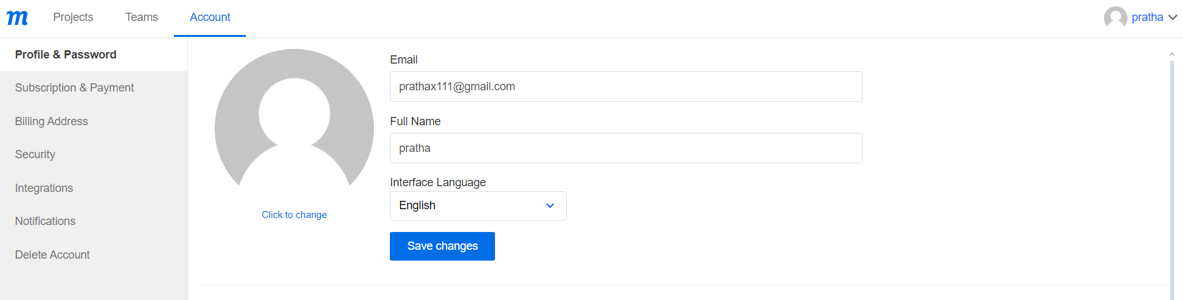

Tools:

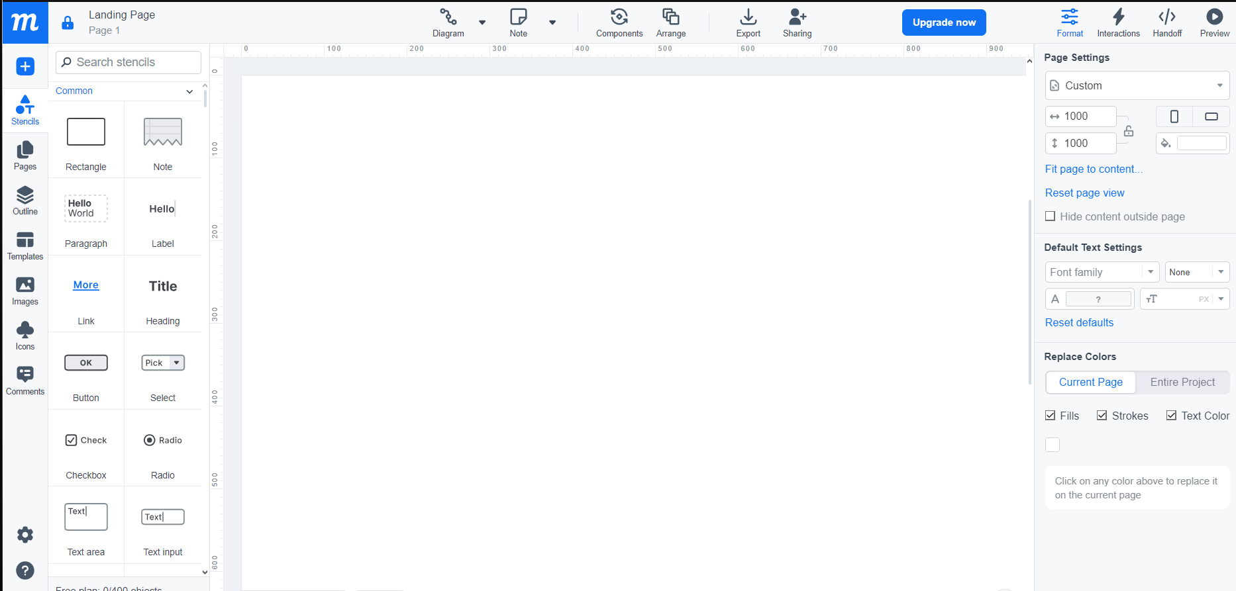

**Task 2 – Design the below like wireframe structure. Use your own creativity**.

Moqups link:

<https://app.moqups.com/MaRkcaZeBnNAg3rhLDEFq771tTGDuBgF/view/page/a54d5d51c>

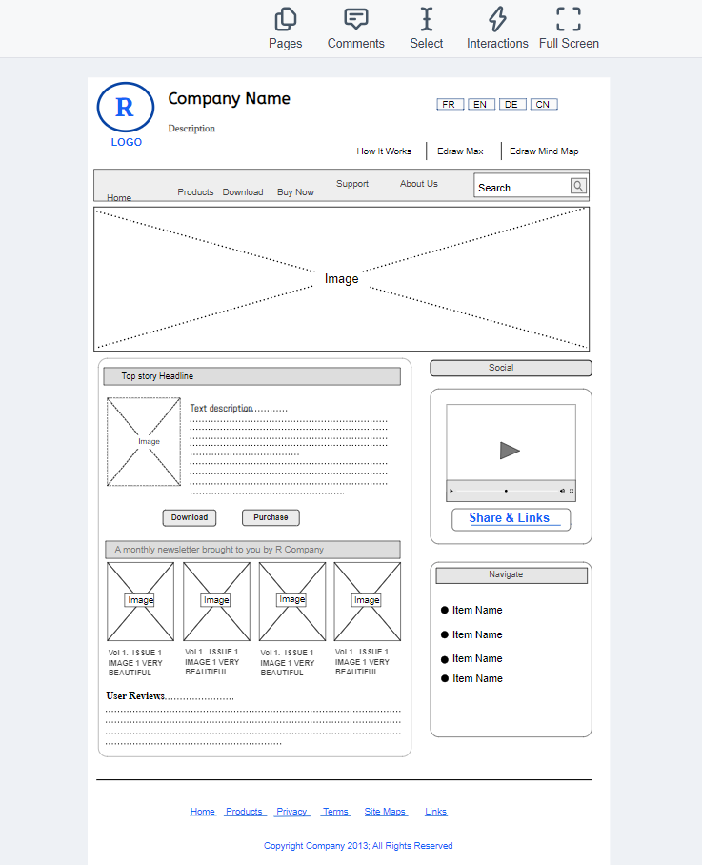

**Task 3 – Create a mockup design like your college website’s contact us page. Use your own creativity for this design.**

